Table 4.1.1 Comparison of Anthropometric Data among Passive smokers, firewood users and cigarette smokers

|  |  |  |  |  |  |
| --- | --- | --- | --- | --- | --- |
| **Parameter** | **Passive smokers n=10** | **Firewood users n=20** | **Cigarette smokers n=20** | **F-value** | **P-value** |
| **BMI (Kg/m2)** | 25.03 ± 4.22 | 25.07 ± 3.74 | 24.04 ± 4.15 | .401 | .672 |
| **Waist Circumference (cm)** | 86.80 ± 11.07 | 88.25 ± 10.58 | 85.85 ± 9.92 | .268 | .766 |
| **Waist/Hip ratio** | 0.85 ± 0.06 | 0.84 ± 0.64 | 0.84 ± 0.4 | .097 | .908 |
| **Systolic BP (mmHg)** | 122.30 ± 12.1 | 126.95 ± 16.06 | 134.15 ± 15.48 | 2.315 | .110 |
| **Diastolic BP (mmHg)** | 77.90 ± 6.77 | 82.90 ± 9.43 | 89.45 ± 13.48 | 4.141 | .022 |

**significant at P-value < 0.01, *significant at P-value < 0.05

Table 4.1.2 Comparison of the level of Cadmium and lead concentration among passive smokers, firewood users and cigarette smokers.

The analysis of variance test (ANOVA) was used to determine the mean difference of cadmium and lead across the three groups. It was observed that there were statistically significant differences within the groups of participant for cadmium (P-value = 0.000 and F = 1.94), as well as lead (P-value = 0.043, F = 3.36). Furthermore, the post hoc table below shows the specific differences within the three group, where statistical significance was taken at P-value < 0.05.

|  |  |  |  |  |  |
| --- | --- | --- | --- | --- | --- |
| **Parameter** | **Passive smokers n=10** | **Firewood users n=20** | **Cigarette smokers n=20** | **F-value** | **P-value** |
| **Cadmium ug/dl** | 0.64 ± 0.13 | 0.75 ± 0.22 | 1.14 ± 0.30 | 18.54 | 0.000** |
| **Lead ug/dl** | 12.55 ± 4.86 | 16.49 ± 5.18 | 17.23 ± 4.34 | 3.36 | 0.043* |

**significant at P-value < 0.01, *significant at P-value < 0.05

Table 4.1.3 Post-Hoc Analysis to determine the difference within the group

|  |  |  |  |
| --- | --- | --- | --- |
| **Group (A-B)** | **Mean difference** | **95% C.I (lower,Upper)** | **P-value** |
| **Cadmium (ug/dl)** |  |  |  |
| **Firewood User-Passive** | 0.11 | -0.12,0.33 | 0.491 |
| **Cigarette smoker- Passive** | 0.49 | 0.26,0.72 | 0.000** |
| **Cigarette smoker- firewood user** | 0.38 | 0.20,0.57 | 0.000** |
| **Lead (ug/dl)** |  |  |  |
| **Firewood User-Passive** | 3.94 | -0.55,8.43 | 0.096 |
| **Cigarette smoker- Passive** | 4.69 | 0.19,9.18 | 0.039* |
| **Cigarette smoker- firewood user** | 0.74 | -2.93,4.41 | 0.877 |

**significant at P-value < 0.01, *significant at P-value < 0.05

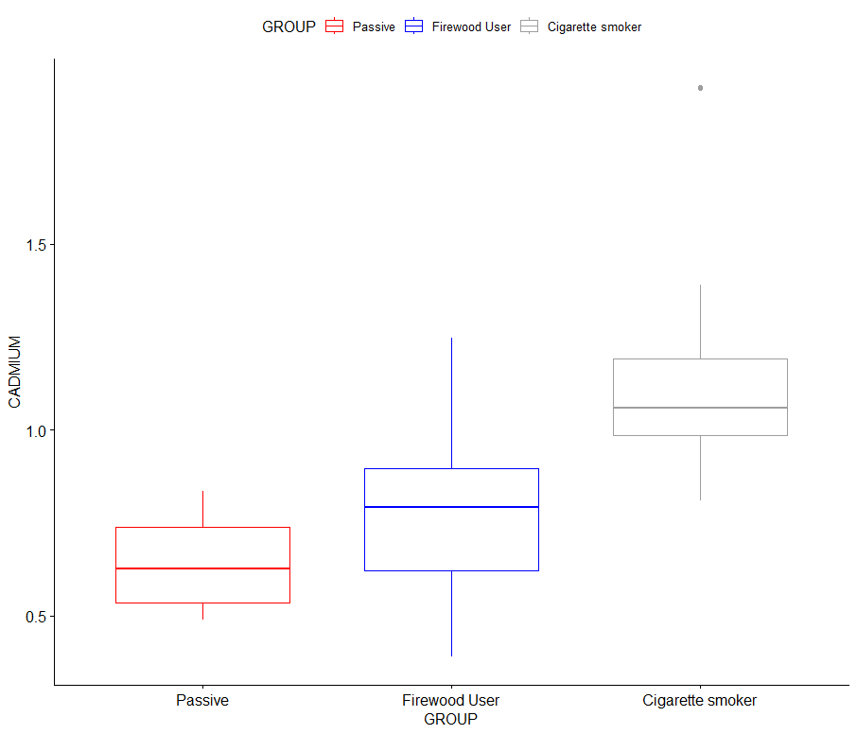

Figure 1. A boxplot showing the level of cadmium within the groups (passive smokers, firewood users and cigarette smokers).

The boxplot above gives a pictorial description of the central of tendency of the level of cadmium across all the groups, it shows the maximum value, upper quartile, median, lower quartile and minimum value

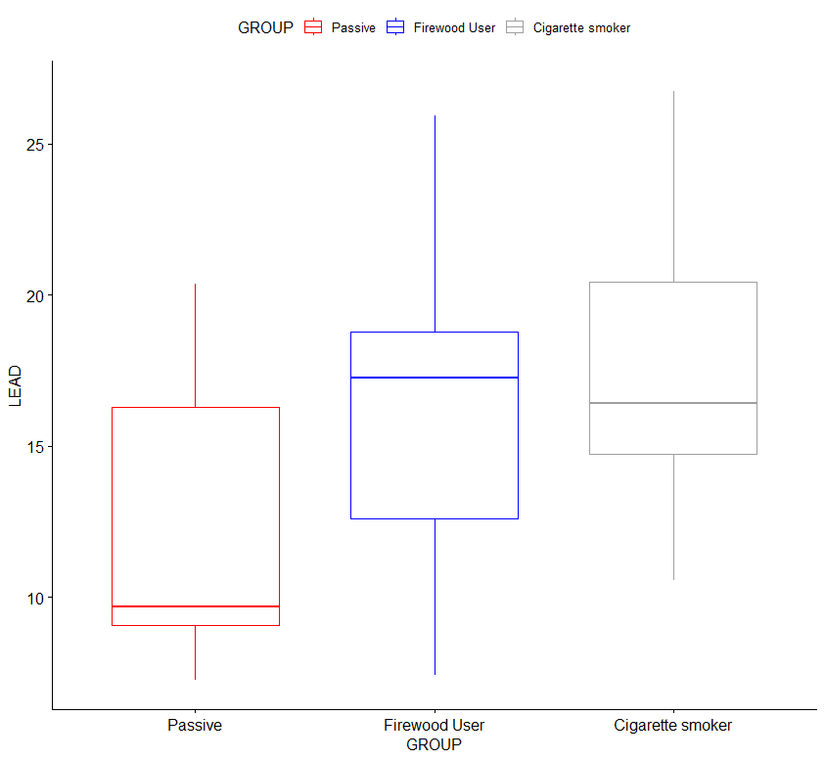

Figure 2. A boxplot showing the level of lead within the groups (passive smokers, firewood users and cigarette smokers).

The boxplot above gives a pictorial description of the central of tendency of the level of lead across all the groups, it shows the maximum value, upper quartile, median, lower quartile and minimum value

Table 4.2 Difference in cadmium and lead concentration between the control group (passive smokers) and the test groups (Firewood users, Cigarette smokers)

|  |  |  |  |  |
| --- | --- | --- | --- | --- |
|  | | **Mean difference** | **t-test** | **P-value** |
| **Parameters** | | **Cadmium (ug/dl)** |  |  |
| Control | Firewood users | 0.11 | 1.69 | 0.102 |
| Control | Cigarette smokers | 0.49 | 6.33 | 0.000** |
| Cigarette smokers | Firewood users | 0.38 | 4.61 | 0.000** |
|  |  | **Lead (ug/dl)** |  |  |
| Control | Firewood users | 3.94 | 2.05 | 0.054 |
| Contro | Cigarette smokers | 4.69 | 2.58 | 0.019* |
| Cigarette smokers | Firewood users | 0.74 | 0.49 | 0.626 |

**significant at p-value < 0.01, * significant at P-value < 0.05

Table 4.3.1 Correlation between lead and renal parameters (urea and creatinine) among the passive

|  |  |  |  |
| --- | --- | --- | --- |
| **Correlation between lead and renal parameters (urea and creatinine) among the passive** | | | |
|  | **Passive smokers** |  |  |
|  | Lead (r, p-value) | Urea (r, p-value) | Creatinine (r, p-value) |
| Lead (r, p-value) | 1 |  |  |
| Urea (r, p-value) | 0.071, 0.846 | 1 |  |
| Creatinine (r, p-value) | 0.265, 0.459 | 0.233, 0.535 | 1 |
|  | **Firewood users** |  |  |
|  | Lead (r, p-value) | Urea (r, p-value) | Creatinine (r, p-value) |
| Lead (r, p-value) | 1 |  |  |
| Urea (r, p-value) | -0.037, 0.878 | 1 |  |
| Creatinine (r, p-value) | -0.193, 0.414 | 0.372, 0.106 | 1 |
|  | **Cigarette smokers** |  |  |
|  | Lead (r, p-value) | Urea (r, p-value) | Creatinine (r, p-value) |
| Lead (r, p-value) | 1 |  |  |
| Urea (r, p-value) | 0.116, 0.627 | 1 |  |
| Creatinine (r, p-value) | 0.322, 0.116 | 0.613, 0.004** | 1 |

**significant at P-value < 0.01, *significant at P-value < 0.05

Table 4.3.2 Correlation between lead and renal parameters (urea and creatinine) among the passive

|  |  |  |  |
| --- | --- | --- | --- |
| **Correlation between Cadmium and renal parameters (urea and creatinine) among the passive** | | | |
|  | **Passive smokers** |  |  |
|  | Cadmium (r, p-value) | Urea (r, p-value) | Creatinine (r, p-value) |
| Cadmium (r, p-value) | 1 |  |  |
| Urea (r, p-value) | -0.222, 0.537 | 1 |  |
| Creatinine (r, p-value) | 0.220, 0.541 | 0.223, 0.535 | 1 |
|  | **Firewood users** |  |  |
|  | Cadmium (r, p-value) | Urea (r, p-value) | Creatinine (r, p-value) |
| Cadmium (r, p-value) | 1 |  |  |
| Urea (r, p-value) | -0.375, 0.103 | 1 |  |
| Creatinine (r, p-value) | -0.335, 0.149 | 0.372, 0.106 | 1 |
|  | **Cigarette smokers** |  |  |
|  | Cadmium (r, p-value) | Urea (r, p-value) | Creatinine (r, p-value) |
| Cadmium (r, p-value) | 1 |  |  |
| Urea (r, p-value) | 0.194, 0.412 | 1 |  |
| Creatinine (r, p-value) | -0.066, 0.781 | 0.613, 0.004** | 1 |

**significant at P-value < 0.01, *significant at P-value < 0.05

Table 4.4.1 Comparison of the level of urea and creatinine concentration among passive smokers, firewood users and cigarette smokers.

The analysis of variance test (ANOVA) was used to determine the mean difference of urea and creatinine across the three groups. It was observed that there were statistically significant differences within the groups of participant for urea (P-value = 0.000 and F = 22.26), as well as creatinine (P-value = 0.003, F = 6.76). Furthermore, the post hoc table below shows the specific differences within the three group, where statistical significance was taken at P-value < 0.05.

|  |  |  |  |  |  |
| --- | --- | --- | --- | --- | --- |
| **Parameter** | **Passive smokers n=10** | **Firewood users n=20** | **Cigarette smokers n=20** | **F-value** | **P-value** |
| **Urea umol/l** | 2.63 ± 0.51 | 3.92 ± 0.94 | 5.16 ± 0.1.21 | 22.26 | 0.000** |
| **Creatinine mmol/l** | 83.82 ± 20.08 | 104.69 ± 21.83 | 123.20 ± 35.82 | 6.76 | 0.003** |

**significant at P-value < 0.01, *significant at P-value < 0.05

Table 4.4.2 Post-Hoc Analysis to determine the difference within the group

|  |  |  |  |
| --- | --- | --- | --- |
| **Group (A-B)** | **Mean difference** | **95% C.I (lower,Upper)** | **P-value** |
| **Urea umol/l** |  |  |  |
| **Firewood User-Passive** | 1.29 | 0.35,2.23 | 0.005** |
| **Cigarette smoker- Passive** | 2.53 | 1.59,3.47 | 0.000** |
| **Cigarette smoker- firewood user** | 1.24 | 0.47,2.01 | 0.000** |
| **Creatinine mmol/l** |  |  |  |
| **Firewood User-Passive** | 20.88 | -5.45,47.20 | 0.144 |
| **Cigarette smoker- Passive** | 39.33 | 13.01,65.65 | 0.002** |
| **Cigarette smoker- firewood user** | 18.46 | -3.04,39.9 | 0.105 |

**significant at P-value < 0.01, *significant at P-value < 0.05

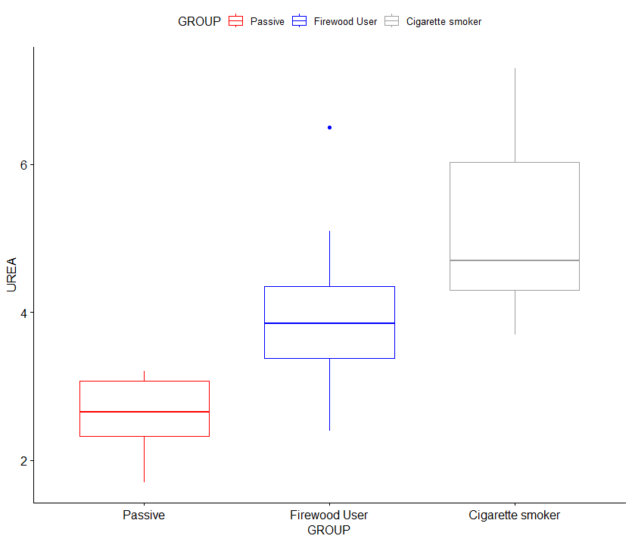

Figure 3. A boxplot showing the level of urea within the groups (passive smokers, firewood users and cigarette smokers).

The boxplot above gives a pictorial description of the central of tendency of the level of urea across all the groups, it shows the maximum value, upper quartile, median, lower quartile and minimum value

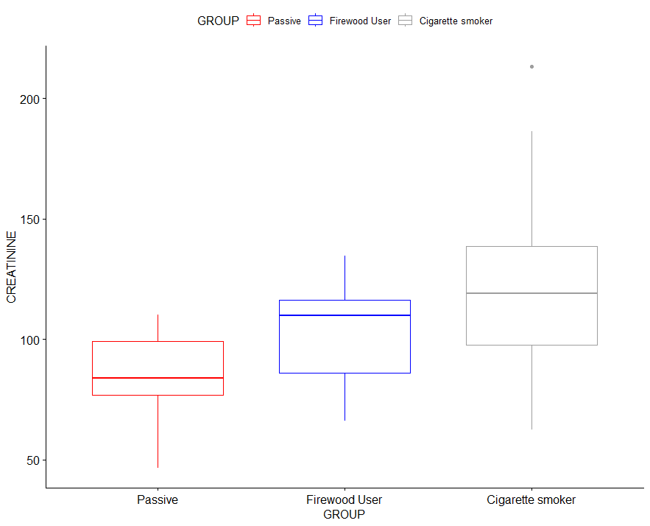

Figure 4. A boxplot showing the level of creatinine within the groups (passive smokers, firewood users and cigarette smokers).

The boxplot above gives a pictorial description of the central of tendency of the level of creatinine across all the groups, it shows the maximum value, upper quartile, median, lower quartile and minimum value

Table 4.5 Difference in urea and creatinine concentration between the control group (passive smokers) and the test groups (Firewood users, Cigarette smokers)

|  |  |  |  |  |
| --- | --- | --- | --- | --- |
|  | | **Mean difference** | **t-test** | **P-value** |
| **Parameters** | | **Urea umol/l** |  |  |
| Control | Firewood users | 1.29 | 4.84 | 0.000** |
| Control | Cigarette smokers | 2.53 | 8.03 | 0.000** |
| Cigarette smokers | Firewood users | 1.24 | 3.61 | 0.000** |
|  |  | **Creatinine mmol/l** |  |  |
| Control | Firewood users | 20.88 | 2.61 | 0.019* |
| Control | Cigarette smokers | 39.33 | 3.85 | 0.000** |
| Cigarette smokers | Firewood users | 18.46 | 1.97 | 0.058 |

**significant at p-value < 0.01, * significant at P-value < 0.05